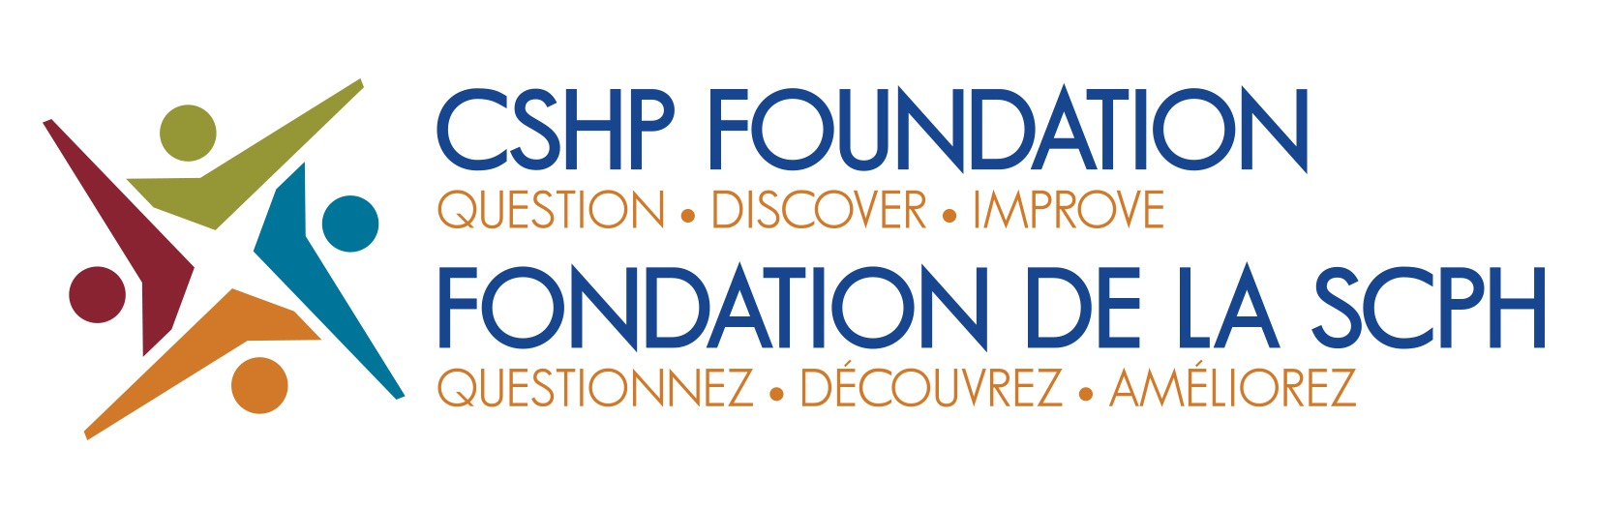

2023 Education Grant Competition
Criteria and Submission Checklist
Thematic Conferences/Educational Programs or Materials Development

Please review the following questions carefully before submitting your education grant application.
Your submission will not be considered if these criteria are not met.
If you need clarification of any criteria, please contact Rosemary Pantalone by e-mail at rpantalone@cshp.ca

 | Criteria and Submission Checklist (a copy of this completed checklist is required with your submission)
❑ | I/we understand that the application will be reviewed by the Education Grant Committee of the CSHP Foundation. An education grant program description is posted on the CSHP Foundation https://cshp-scph.ca/foundation-education-grants  Grant decisions will be announced in January 2024. The Education Grant Committee reserves the right to revise the funding amount requested by the Principal Applicant.
❑ | The Principal Applicant is a CSHP Member, Member-in-Training, or Student Supporter and has been a member for at least 12 months at the time of the grant application. A single Principal Applicant must be specified, and their CSHP  Membership Number must be provided.
❑ | This is the sole application to this grant competition for the Principal Applicant Principal (applicant may only be awarded a grant every two years).
❑ | This application is not being submitted on behalf of a CSHP group (committee, task force, or affiliated board).
❑ | The application describes a thematic conference development or development of educational programs or materials for pharmacists.
❑ | This application does not duplicate funding already held for this project or a portion of the project. If an additional funding source is being solicited, please declare the funding source and decision date for that funding source.
❑ | The education grant requested in this application will not fund conference attendance or travel to attend a conference, residency or fellowship programs, enrollment in an accredited academic degree programs, or research projects  The purpose of the grant competition is not to fund educational opportunities for learners that would be undertaken within their training program regardless of external funding. However, if a portion of learner education is novel and includes an educational initiative that requires external funding, this should be explicitly stated and justified in the rationale and budget of the project, including an explanation of in-kind contributions from the sponsoring institution.
❑ | The complete submission contains the following as 5 (or 6) distinct documents:  - Completed checklist  - Title page that contains the name and contact information of the Principal Applicant, CSHP number, grant type,  project title, co-applicant names with contact information.  - Written proposal., See Education Grant Program Description, available at https://cshp-scph.ca/foundation-education-grants for required elements of each grant type. These should be clearly defined to enhance the quality of your submission.  - Budget, not to exceed $5,000 (template provided: justification for each item is required)  - Letter of support from applicant’s employer(s).  - Curriculum vitae of the Principal Applicant.
Your complete submission/application package must be submitted electronically to Rosemary Pantalone (rpantalone@cshp.ca) and all files must be in PDF format. DEADLINE DATE FOR SUBMISSIONS: October 14, 2023.

